The CPRI Brake Shop Tic Management Group:

Be a Tic Detective!!!

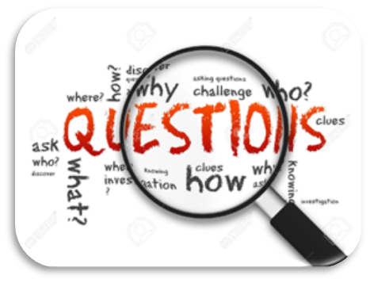

***Get to know the Tic you’ve chosen to work on:*** *we need to know it REALLY well in order to boss it back! Think carefully about it, watch yourself in a mirror, or ask someone else to watch you or even model the tic.*

***The questions below are only ideas to get you started:*** *you don’t have to answer all of them, or ones that don’t make sense for your Tic.*

*See if you can come up with your own, better questions!*

How Does Your Tic Look and Sound? **Is it…**

|  |  |  |  |  |  |
| --- | --- | --- | --- | --- | --- |
| A Word? | 🞏 | Loud? | 🞏 | Fast? | 🞏 |
| A Sound? | 🞏 | Soft? | 🞏 | Slow? | 🞏 |
| A Movement? | 🞏 | Which side is it on?  Left 🞏 Right 🞏 Both 🞏 |  | Med? | 🞏 |

# Describe Each Step In Order…

|  |  |
| --- | --- |
| What happens ***first***?      What happens ***next***?    What happens ***after*** ***that***? |  |
|  |
|  |

# What Else Happens When This Tic Comes Around?

|  |  |
| --- | --- |
| Are you ***moving any other part of your body*** during the tic?  -e.g. moving your forehead, cheeks,  or neck during a blinking tic? |  |
| Do you ***tense*** or ***lift*** any part of your body when you do the tic? |  |
| Other things ***you’ve*** noticed? That ***others*** have noticed? |  |



# What Are The ‘Warning Signs’ For This Tic?

***How do you know the tic is coming,*** *or what it is you feel when you suppress (“hold in”) your tic? What “clues” is your body giving you to figure out when that Tic is going to show up again???*

***Before that Tic comes out, I feel a(n)…***

|  |  |  |  |  |  |  |
| --- | --- | --- | --- | --- | --- | --- |
| Itch | 🞏 | Tightness | 🞏 | Build up of air | 🞏 | |
| Tickle | 🞏 | Wet | 🞏 | Feeling I have to do it | 🞏 | |
| Pain | 🞏 | Tingle | 🞏 | Pressure | 🞏 | |
| Other | 🞏 ________ | I take a deep breath before I do it | | | 🞏 | |
| Other things your body is doing ***when*** or ***right after*** that Tic shows up:  _______________________________________________________________ | | | | | |  | |

# Certain Places, Times, or Activities…

|  |  |
| --- | --- |
| Is there a ***certain*** ***place*** where the tic comes out the most?  *Is there a* ***certain activity*** *where your tic comes out more*?  Is there a ***time of day*** that this Tic gets worse?  What ***one situation*** is guaranteed to make your Tic happen?  Do you notice a certain feeling (emotion) that the tic likes to take advantage of?  Is there a certain person or group of people that your tic likes to hang around with the most? |  |
|  |
|  |
|  |
|  |
|  |

# Now that we know all of this, what ways could we “starve” this Tic?

**1**

**2**

**3**

**4**